**FINAL PROJECT REPORT**

**TOPIC: LTE NETWORK SIMULATION USING NS3**

BY:

MONICA NETHAGANI

[mnethaga@uncc.edu](mailto:mnethaga@uncc.edu)

801039607

**Abstract:**

The main objective of the project is to understand the functionality of LTE network using nsnam’s ns-3 Simulator and have implemented the Handover, Mobility and Scheduler algorithms on the designed network. Handovers are needed in cellular systems to maintain mobility and acceptable link quality without causing unnecessary co-channel and adjacent channel interference. Within handover algorithm, one protocol is implemented namely “A2A4 Rsrq handover” protocol. And the scheduler used is “pf-ff-mac scheduler” model.

**Introduction:**

NS-3 simulator is an open source software publicly available under the GNU GPLv2 license for R&D uses. It is used for simulating network topologies. The goal of ns-3 simulator is to develop a preferred, open simulation environment for networking research. NS-3 can run C++ and Python scripts.

**Aim of this project:**

This project has worked towards designing a network topology that contains 3 antenna nodes and 4 user nodes. In the designed topology, there are 3 stationary users and one user which moves from one end to another end. During this process, there will be two handovers being done. When the moving user comes closer to one of the antennas, the user will get disconnected from the connected antenna and gets handed over to the nearest antenna. In this project, the user gets handed over two times.

**Handover**:

Handover procedures are a key function of LTE eNBnodes.

**Proportional fair Scheduler:**

This is the pf-ff-mac-scheduler model. It is a compromise-based [scheduling algorithm](https://en.wikipedia.org/wiki/Scheduling_algorithm). The proportional fair scheduler algorithm is based on to maintain a balance between two competing interests: To try to maximize total throughput and at the same time allowing all users having at least a minimal level of service. This is done by assigning each data flow a data rate or a scheduling priority that is inversely proportional to its anticipated resource consumption.

There are 3 local antennas, 4 users, one packet data network gateway and one as shown below. The antennas are marked as nodes2,3,4 and users as nodes 5,6,7,8 among which user node 8 is the moving user and node 0 is the pgw.

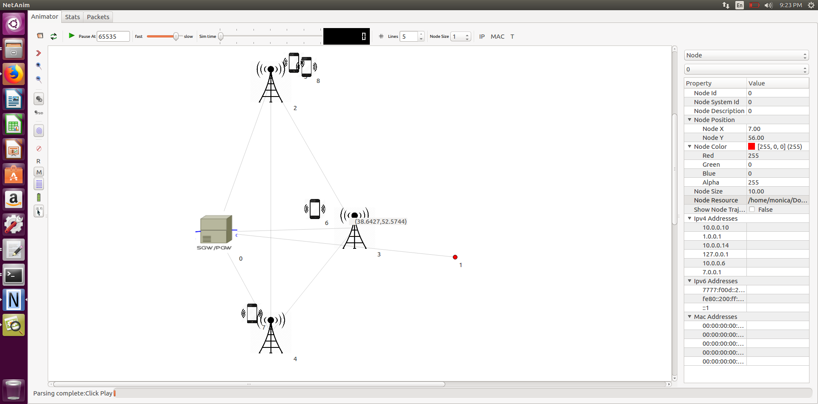

Initially, user nodes 5,8 are near antenna node 2; user nodes 6 and 7 near antenna nodes 3 and 4 respectively.

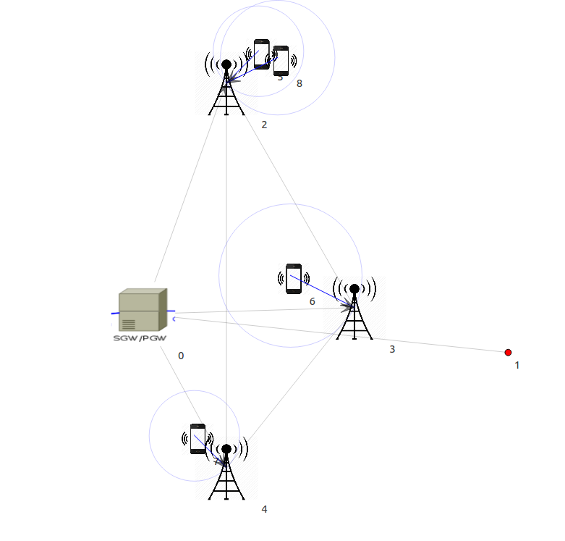

As we can see, the user 8 is in motion and is given signal by antenna 2:

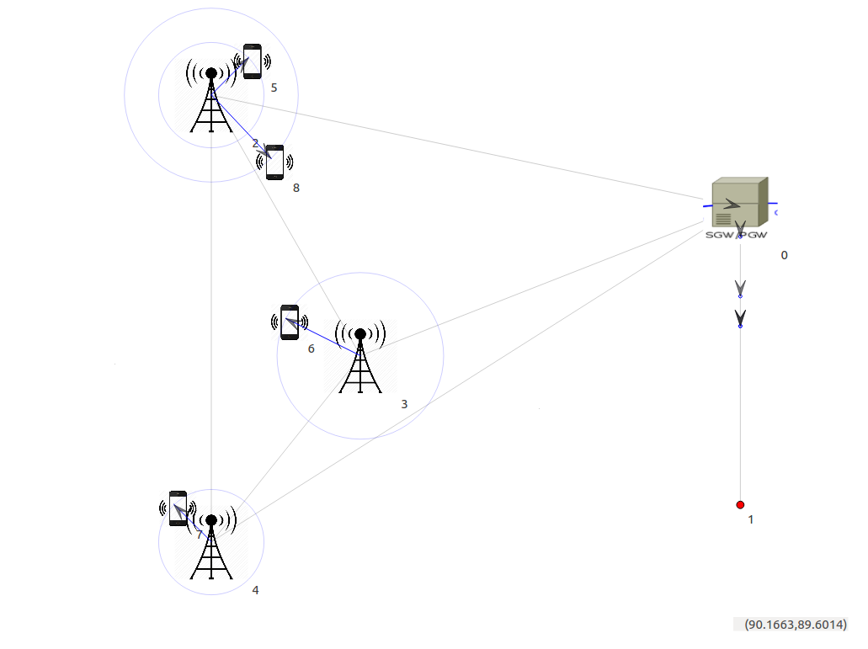

Now, the user 8 has reached in the limits of antenna 3 and hence receives the signal from antenna 3:

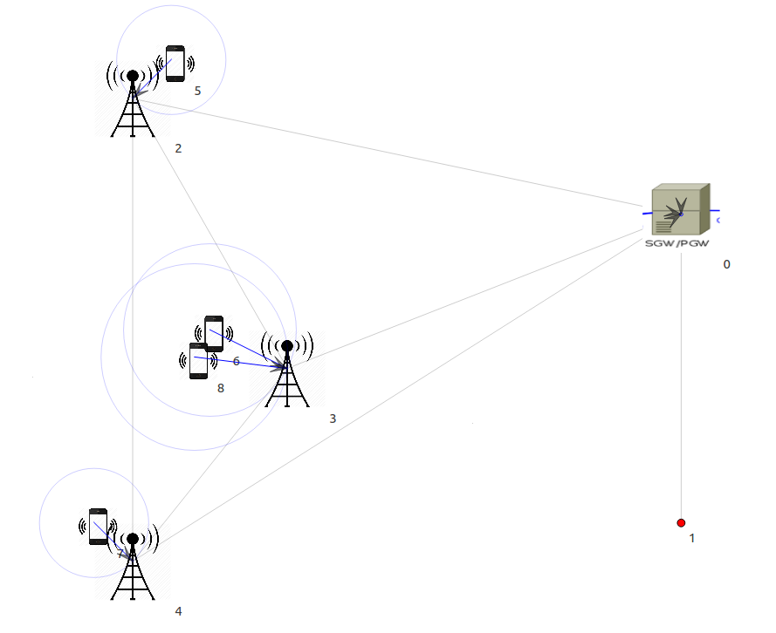

The user 8 gradually moves down and now is in the range of antenna 4 and hence receives the signal from antenna 4 as shown:

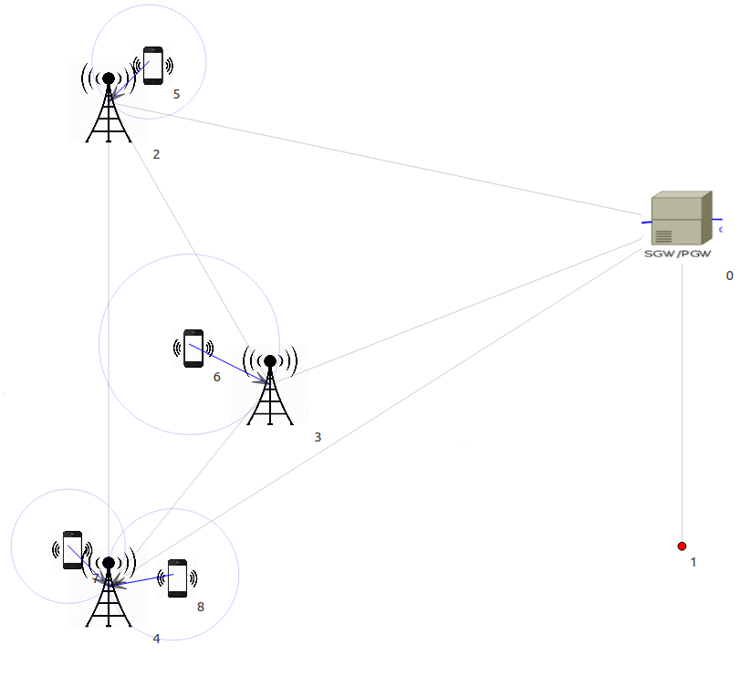

The flow monitor charts obtained during the process are as shown:

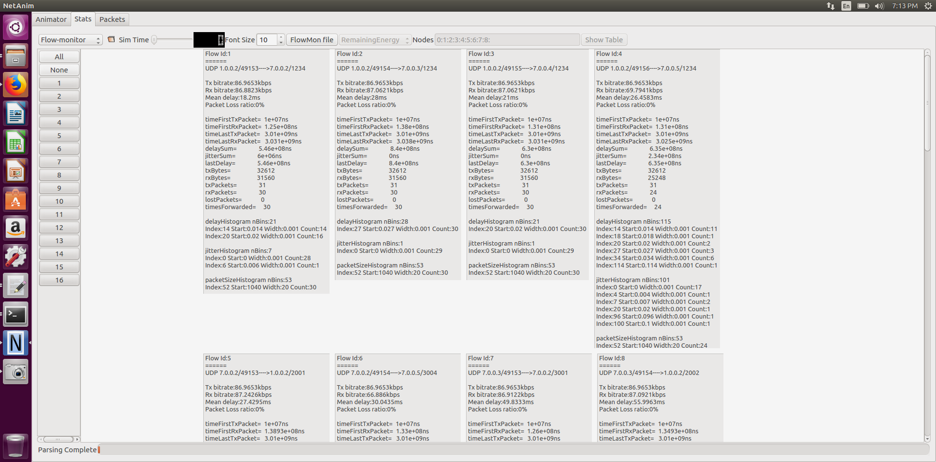

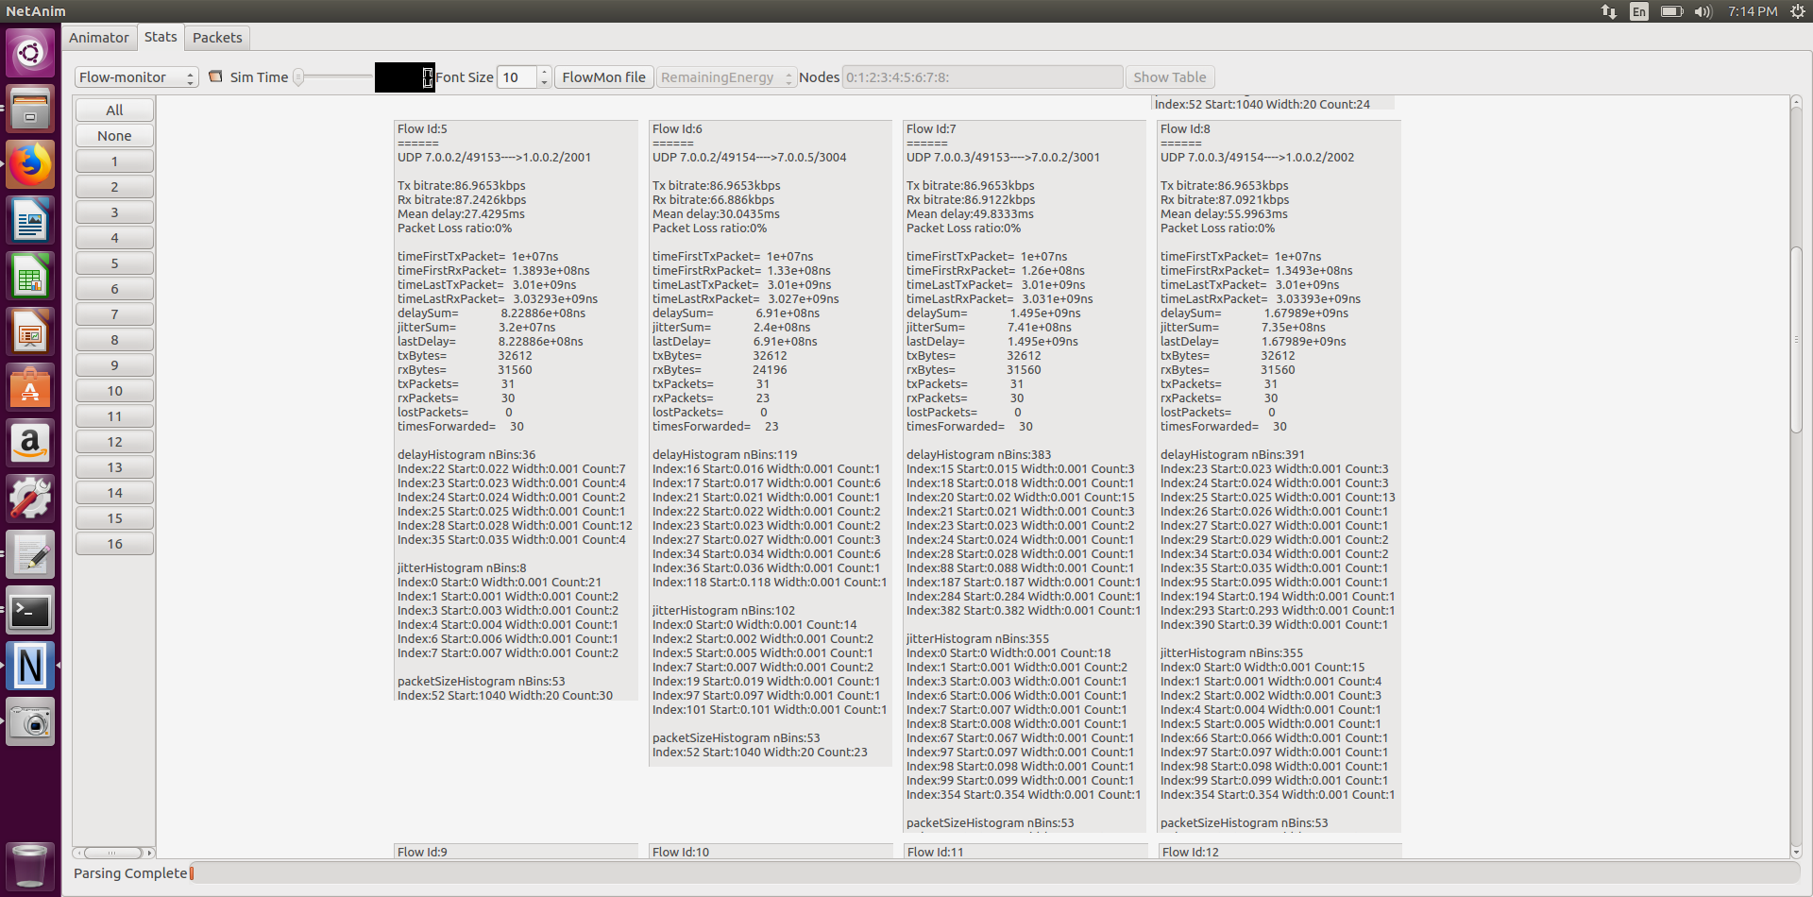

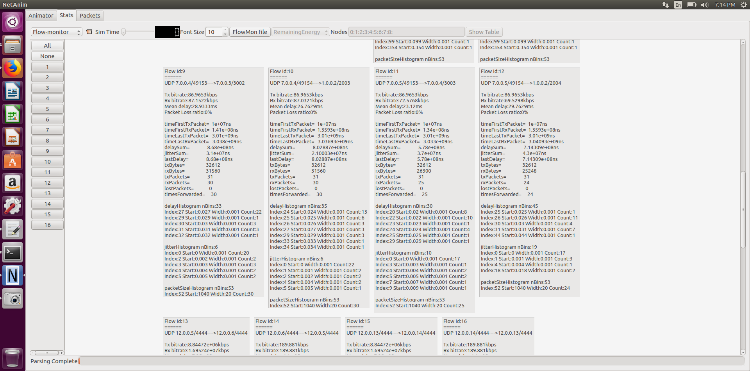

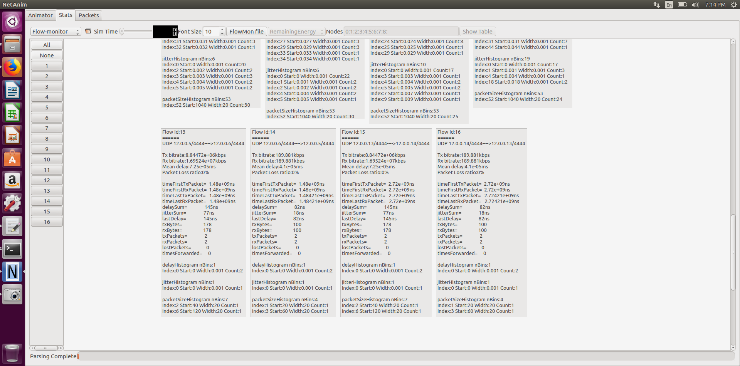

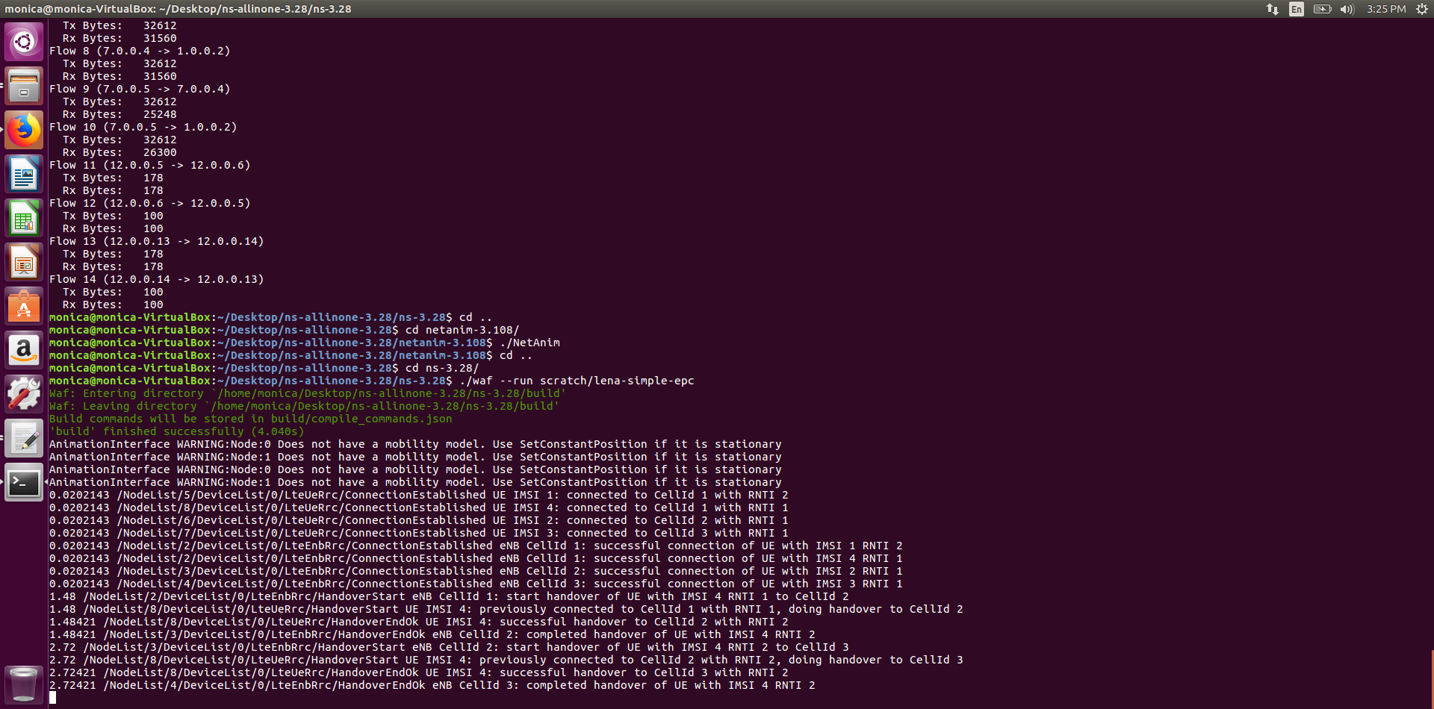

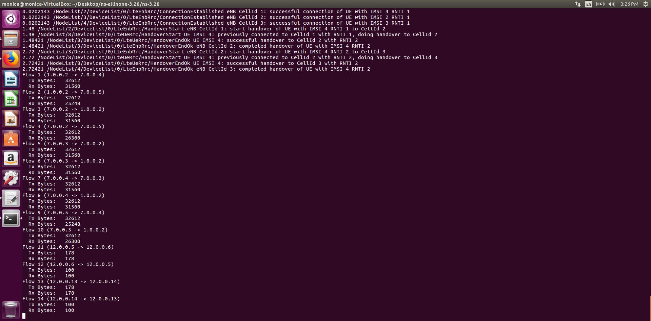

The following code initializes the handover algorithm and the scheduler:

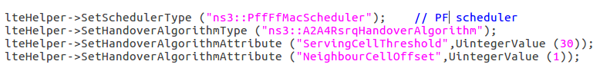

The following code is used for flow monitoring process:

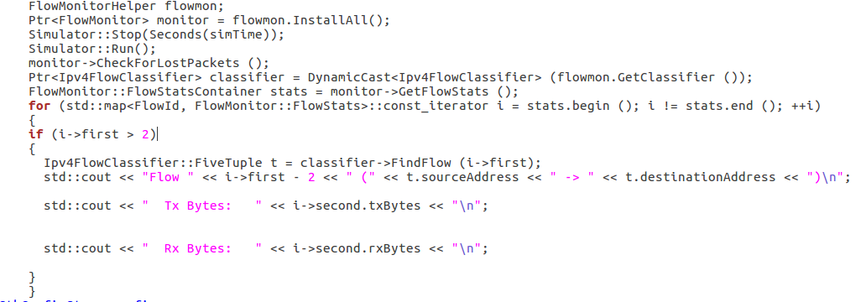

The enbnodes and the user nodes are defined and initialised in the following code:

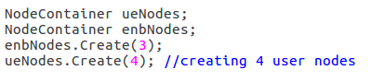

The netanim is used by declaring the following code:

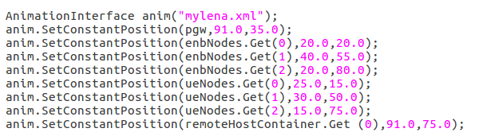

In the above code, the position for each node is defined.

The following code is used to find out the throughput:



The throughput is as follows:

